INT217 : INTRODUCTION TO DATA MANAGEMENT
PROJECT REPORT
(Project Semester January-April 2025)

FIFA World Cup Match Results

Submitted by

Chandan yadav

Registration No 12319066

Programme and Section – B.Tech (cse), K23VM
Course Code - INT217

Under the Guidance of

Anchal kaundal

Discipline of CSE/IT

Lovely School of Computer and Engineering

Lovely Professional University, Phagwara

CERTIFICATE

This is to certify that Chandan yadav bearing Registration no. 12319066 has completed .INT217 project titled, “FIFA World Cup Match Results” under my guidance and supervision. To the best of my knowledge, the present work is the result of his/her original development, effort and study.

Signature and Name of the Supervisor
Designation of the Supervisor
School of Computer and Engineering
Lovely Professional University
Phagwara, Punjab.

Date: 12/04/2025

DECLARATION

I, Chandan yadav student of B.Tech under CSE/IT Discipline at, Lovely Professional University, Punjab, hereby declare that all the information furnished in this project report is based on my own intensive work and is genuine.

Date: 12/04/2025 Signature
Registration No. 12319066 Chandan yadav

1. Introduction
This project focuses on analyzing historical FIFA World Cup results data to understand trends, patterns, and insights into international football performance. Using this data, we aim to extract meaningful information that can assist sports enthusiasts, analysts, and federations in understanding competitive dynamics over the years.

2. Source of Dataset
The dataset was sourced from:
https://public.tableau.com/app/learn/sample-data

3. Dataset Preprocessing
Removed duplicates.
Fixed inconsistent team name entries.
Converted Year and Date to proper datetime format.
Verified numerical values for Goals, Matches, and Attendance.
Categorical fields (Home Team, Away Team, Result) standardized for analysis.

LinkedIn post:
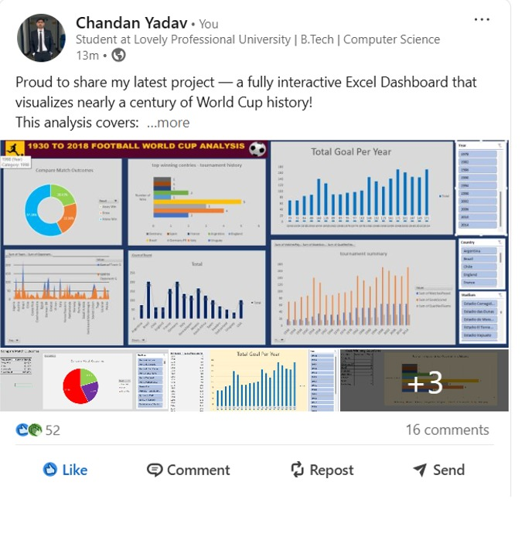

Dash board of project of excel:
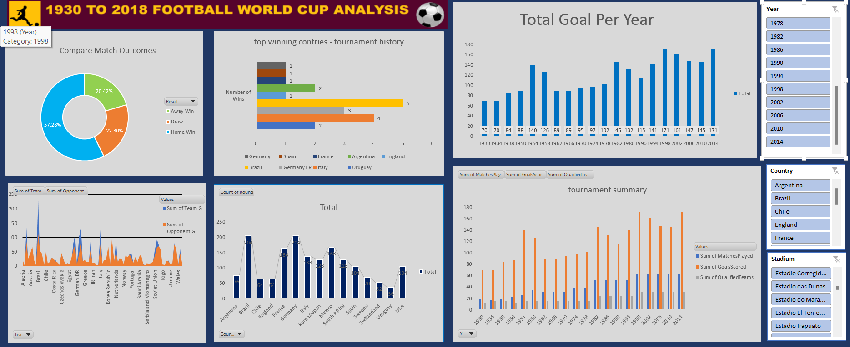

4. Objective-Wise Analysis
A: Analyze Team Performance
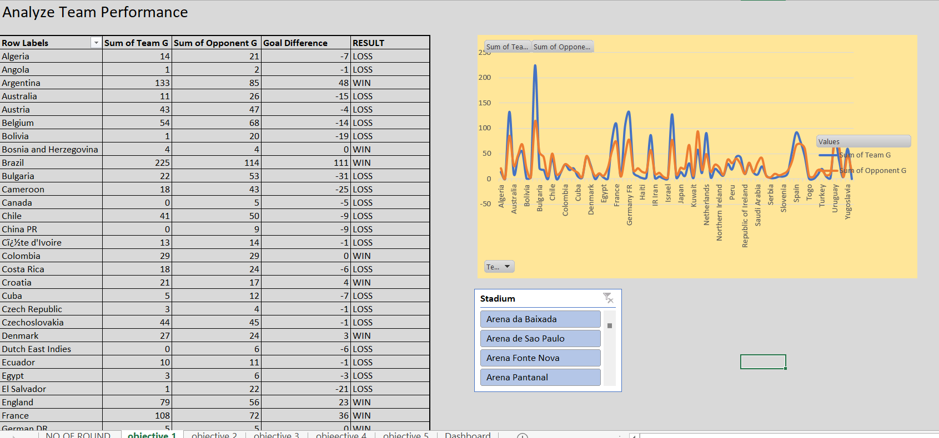

B: Track Goal-Scoring Trends Year-Wise
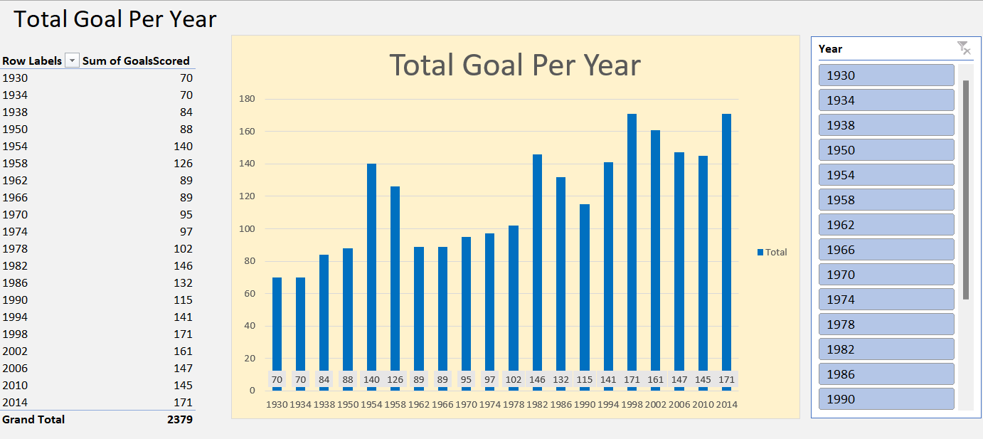

C: Compare Match Outcomes (Home Win, Away Win, Draw)
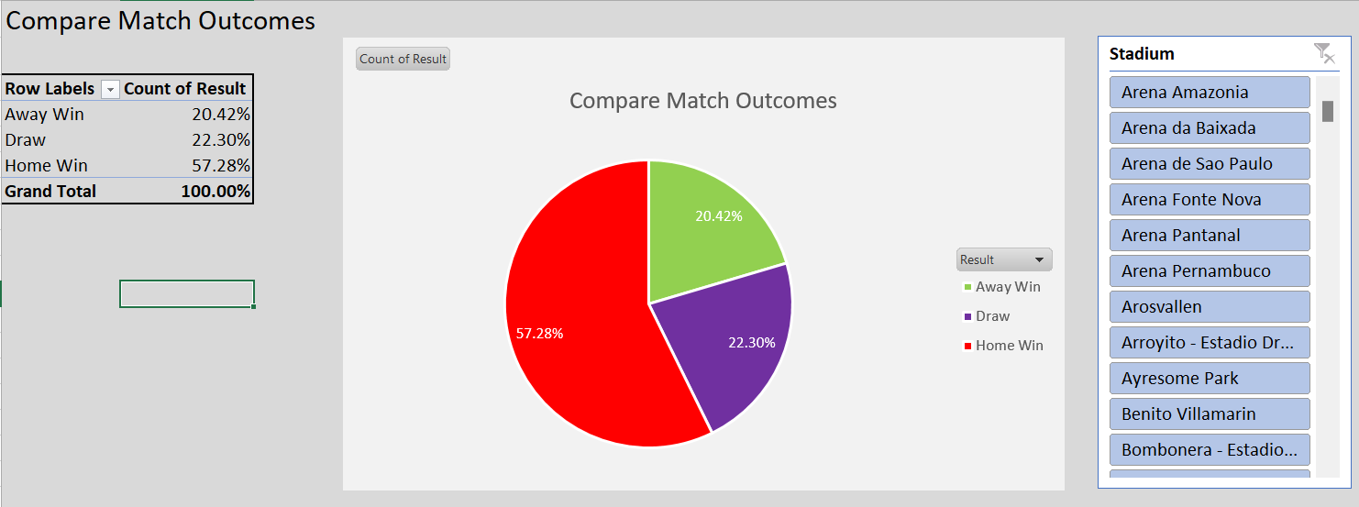

D: Tournament Summary (Attendance, Matches, Goals, Teams)
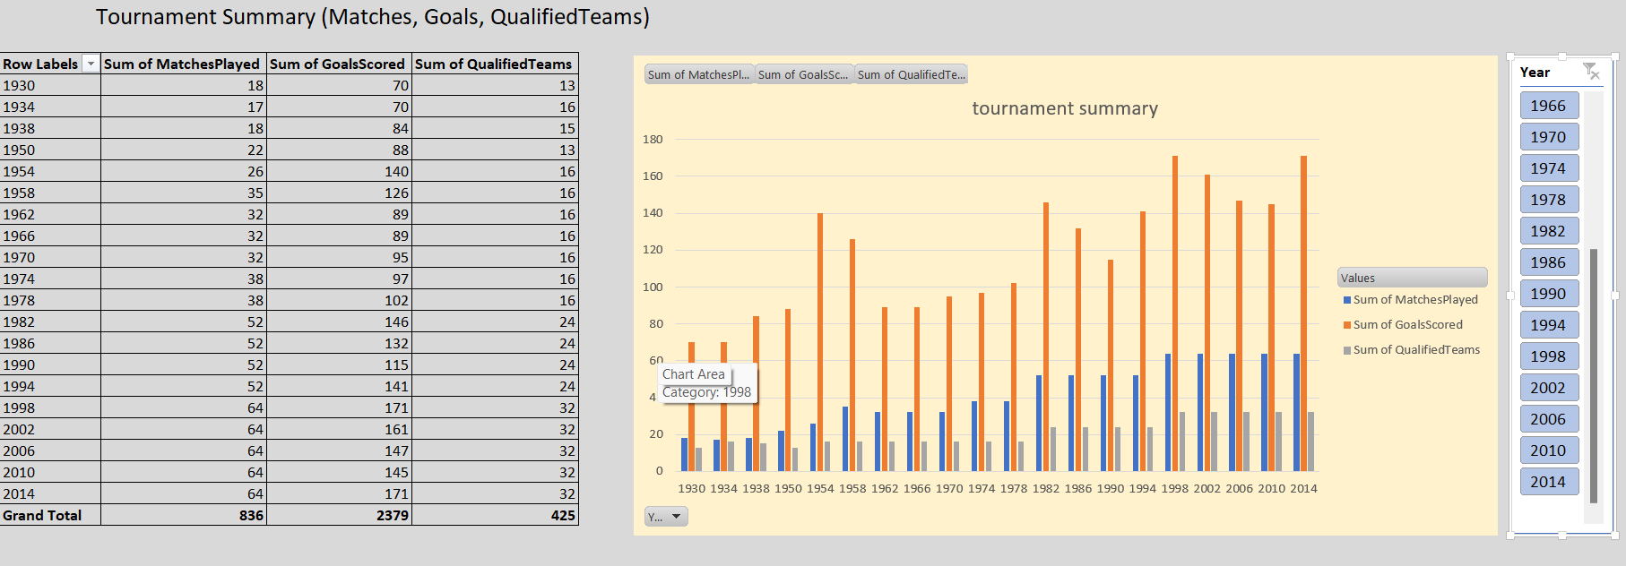

E: Track Winning Countries
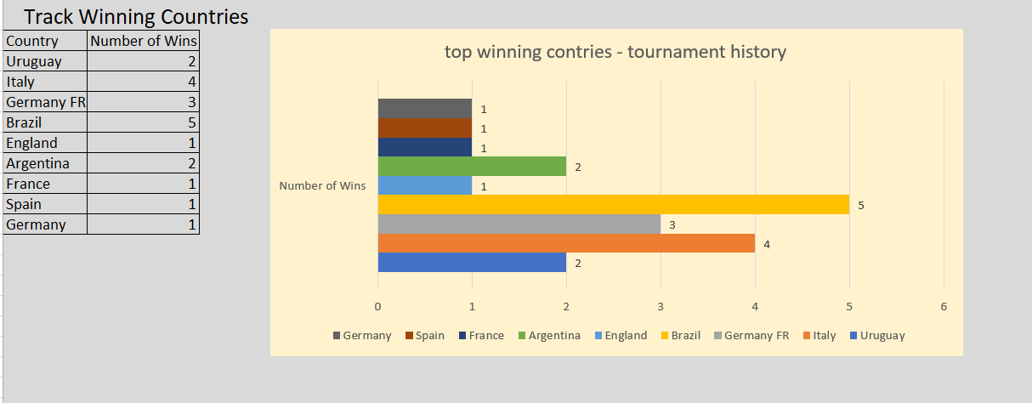

5. CONCLUSON:
The analysis demonstrated consistent performance by a few dominant countries, revealed changing goal-scoring patterns over time, and showed how match outcomes and audience interest evolved. The insights highlight the growth of the sport and the tactical changes that shaped modern football.

6. Future Scope:
Player-level analysis (top scorers, MVPs).
Predictive modeling for upcoming tournaments.
Analysis of geographical or confederation-based trends
Visual dashboards for interactive data exploration.

7. 📚 References
FIFA Official Database: https://www.fifa.com
Tableau Sample Data: https://public.tableau.com/app/learn/sample-data

